Lab Programs
SET-1

- Write a Pandas program to select the distinct department id from employees file.

Aim
To write a Pandas program to display the distinct department IDs from the employees dataset.

Algorithm
- Import the Pandas library.
- Read the employees CSV file.
- Select the department_id column.
- Use the unique() function to find distinct department IDs.
- Display the result.

Dataset (employees.csv)
Employee_ID | First_Name | Last_Name | Department_ID | Job_Title | Salary
101 | John | Smith | 10 | Manager | 75000
102 | Alice | Brown | 20 | Analyst | 55000
103 | David | Wilson | 10 | Manager | 72000
104 | Emma | Thomas | 30 | Clerk | 35000
105 | James | Martin | 20 | Analyst | 56000
106 | Sophia | Lee | 40 | Developer | 65000

Code
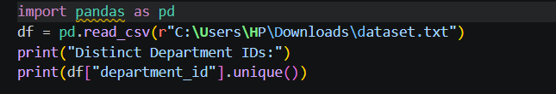

Output


Result
Thus, the distinct department IDs were displayed successfully.

2. Pandas Program to Display the IDs of Employees Who Have Done Two or More Jobs

Aim
To display employee IDs of employees who have worked in two or more jobs.

Algorithm
- Import Pandas.
- Read the employee history dataset.
- Group records by employee ID.
- Count the number of jobs.
- Display employee IDs having job count greater than or equal to 2.

Dataset (job_history.csv)
Employee_ID | Job_Title
101 | Manager
101 | Analyst
102 | Developer
103 | Clerk
103 | Manager
104 | Analyst
105 | Developer
106 | Clerk

Code
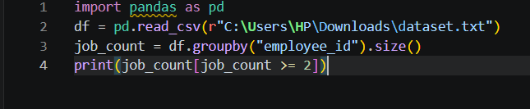

Output
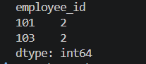

employee_id
101 2
103 2
dtype: int64

Result
Thus, the employee IDs having two or more job records were displayed successfully.

